
WAYNE CENTRAL SCHOOL DISTRICT
BOARD OF EDUCATION MEETING AGENDA

September 25, 2008 6:15 p.m. District Office Conference Room

6:15 Tour of Maintenance, Transportation and Athletics Facilities

7:00 Call to Order
Pledge of Allegiance

Approval of Agenda/Approval of Minutes Att. 1
7:05 Public Comment

7:10 Board Member Comments

7:15 Board President Comments

7:20 Superintendent’s Report
- Summer School Programs Update: Att. 2
Middle School Bridge Program
Elementary Reading Program
- Youth Assistance Program (YAP) Att. 3
- Student Representative
- Student Questions

8:00 Audit Report

8:10 Four County Report

8:15 Public Comment
8:20 Board Member Comments

8:25 Adjournment

Next Meeting Date: October 9, 2008 7:00 p.m. District Office

District Mission Statement
Based on the belief that all students can learn, the staff of the Wayne Central School District accepts the responsibility to teach all students, regardless of differences, the fundamental skills. We further accept the responsibility to challenge all students to attain higher levels of achievement. Wayne Central will provide the opportunity, environment, and encouragement to meet this goal while developing the whole child, physically, socially, emotionally, and culturally.
Att. 1

WAYNE CENTRAL SCHOOL DISTRICT
Ontario Center, New York 14520

BOARD OF EDUCATION MINUTES UNOFFICIAL UNTIL APPROVED

DATE: Thursday, September 11, 2008 TIME: 7:00 p.m.
TYPE: Regular Business Meeting PLACE: District Office

PRESENT: Members Griswold, Lyke, Newman, Nicholson, Paz, Robusto, Schultz, Triou; District Clerk Switzer; Administrators Havens, Siracuse, Shaffer, La Ruche, Schiek, Atseff, Cox, Callahan

ABSENT: Mrs. Brunner

GUESTS: Visitor’s Roster filed in clerk’s agenda file, this meeting

I. CALL TO ORDER: 7:00 p.m. by Frank Robusto, Jr., School Board President

II. PLEDGE OF ALLEGIANCE

III. MOMENT OF SILENCE ● REMBRANCE OF SEPTEMBER 11, 2001

Mr. Robusto requested a moment of silence in remembrance of the 3,000 victims of the terrorist attacks on the United States on September 11, 2001.

IV. APPROVAL OF AGENDA & MINUTES (August 14, 2008)

Mr. Griswold offered a MOTION, seconded by Mr. Nicholson, to approve the agenda for this evening’s meeting and the minutes of the meeting of August 14, 2008, each as presented. Mr. Paz asked if steps are planned to monitor omissions which lead to the tenure by estoppel action at that meeting. Mr. Havens stated they are. 8 Ayes, 0 Nays, 1 Absent (Mrs. Brunner), Carried.

V. PUBLIC COMMENT – None

VI. BOARD MEMBER COMMENTS

- Mr. Griswold noted large crowds at high school field events that illustrate participation by families and residents in school activities has resumed.

VII. BOARD PRESIDENT’S COMMENTS

- Mr. Robusto extended condolences to Mrs. Lyke on the passing of her husband, George.

- Mr. Robusto extended condolences to the family of Bea Lang, a retired bus driver (20 years service)

VIII. REPORT ON ACTION ITEMS BY THE SUPERINTENDENT OF SCHOOLS - None

IX. REPORTS OF THE SUPERINTENDENT OF SCHOOLS

- OPENING DAY REPORT ● 2007-2008 SCHOOL YEAR

Mr. Havens reported that opening day was very smooth for students and staff with third day enrollment at 2,545 students, a decrease of 22 from last year. He noted that the district-wide enrolment projections made by Mr. Switzer varied from actual by three (3) students.

He noted that both the senior project and International Baccalaureate (IB) programs were started and the IB flag is now posted in the flag display in front of the high school.

Mrs. Lyke relayed comments she has received from parents and others on the excellent job by our staff to insure that students and their parents and guardians feel welcome to our schools.

- UPDATE ON POTENTIAL CAPITAL IMPROVEMENT PROJECT

Mr. Havens presented a progress report on the proposed capital facilities project for consideration by the Board of Education.

He summarized the components of a potential capital improvement project, as follows:

- Add a science classroom at the high school
- Add lockers and upgrade the library-media center at the middle school
- Add classrooms to Ontario Primary School to add Grades 3-5 from Ontario Elementary School
- Maximize energy savings and conservation, including a wind turbine on the Ontario Center campus
- Create inter-campus roadway linking east and west portions of the Ontario Center campus and updated access to the athletic field complex by emergency vehicles & personnel

He noted highlights of the meeting in Albany yesterday (September 10, 2008) of school officials and the architect’s office with project managers at the NYS Education Department, which are generally summarized as follows

> Request for waiver for additional state aid was presented with emphasis on efficiency

- State project managers requested additional information on savings and costs of merging Ontario Elementary School and Ontario Primary School into a single K to 5 school

- Revised plans for use of space and deployment of personnel are due to Albany in one ( 1) week

- Within approx. one (1) month, the NYS Education Department will determine the amount of state aid for which the potential capital project is eligible

- State regulations have changed and wind turbines are now eligible for construction aid if part of capital improvements to instructional space

- Engineers who worked with the wind turbine at Harbec Industries in Ontario are participating in discussions with the school district

Mrs. Lyke asked what expectations the NYS Education Department has for future use of Ontario Elementary School. Mr. Havens stated that although not eligible for state aid, state officials were receptive to our proposed uses for district offices, technology support, teacher resource center, meeting & event space and potential municipal purposes.

Mr. Griswold asked for clarification of cost estimates for the potential capital improvement project. Mr. Atseff stated $25 to $35 million dollars, depending on the final scope of a project.

Mr. Triou asked when a special district election might occur; Mr. Havens stated possibly in March, 2009.

Mr. Paz asked what other options were reviewed to meet the capital improvement needs outlined in the long-range facility plan. He noted several maintenance items listed as top priority at Freewill Elementary School, for example, and asked if options for a district-wide K to 5 school were explored.

Mr. Havens stated that the Board of Education did consider a single K to 5 school and decided not to pursue such an approach at this time. The proposals for additional classrooms to shift grades 3, 4 & 5 now at Ontario Elementary School at Ontario Primary School were developed to allow for future expansion to accommodate more classrooms if a single K to 5 school is pursued in the future. He added that each individual capital project is eligible for state building aid.

Mrs. Lyke stated that the Board of Education gave careful thought to a single K to 5 school but decided it was not the proper approach to take.

Mrs. Newman asked Mr. Havens to review the potential staffing changes that would occur if a single K to 5 school were pursued. Mr. Havens stated that, depending on student enrollment levels, consolidation to, varying degrees, could occur in art, music, physical education, library-media, food service, maintenance, school health services and clerical staff.

Mr. Robusto asked about economies for utilities in a single K to 5 school. Mr. Havens stated some economies might exist.

Mr. Paz asked what uses are planned if Ontario Elementary School is no longer used for classrooms. Mr. Havens reviewed potential uses (e.g. district offices, tech support, central stores, teacher resource center). Mr. Paz asked about potential shared uses with the Town of Ontario. Mr. Havens stated that preliminary discussions for shared uses have occurred.

Mr. Triou asked if the school district could use capital reserve funds for repairs at Ontario Elementary School if the space were leased but no longer used for instructional purposes. Mr. Havens stated that use of the funds could occur but state aid is only available for instructional uses.

Mr. Paz stated that the perhaps in ten (10) years the district would have a single campus.

Mr. Havens anticipates that the NYS Education Department will confirm the eligibility for state aid within one (1) month at which time the Board of Education can further consider the topic.

Mr. Nicholson asked how much planning has occurred on a wind turbine; Mr. Havens reviewed efforts to date. Mr. Nicholson noted that a site for a wind turbine on school property would need to meet average wind speeds to meet eligibility guidelines of the NYS Energy Research & Development Agency (NYSERDA).

- STUDENT REPRESENTATIVE

Samantha La Barge, a senior class officer, reviewed senior class activities and school-wide efforts to plan for Homecoming Weekend. She added that she spent a month in Bolivia as an exchange student this summer and her host sister will make a return exchange to our high school this winter. Our high school is also hosting four (4) exchange students this school year..

- STUDENT QUESTIONS

- Jaymi Seitz, 623 Whitney Road, Ontario, asked if the gym would remain available if Ontario Elementary School were no longer used for classrooms; Mr. Havens stated it would.,

- Tori Gillern, 3946 Orchard Street, Walworth, asked about the location of a wind turbine on the school campus; Mr. Havens reviewed possible locations.

- Alex Pera, 5766 Coppersmith Trail, Ontario, asked when we would see wind turbines on school property; Mr. Havens stated that a capital project could extend into the fall of 2010 or spring of 2011.

- Alex Pera, supra, asked about funding for a wind turbine; Mr. Havens stated that the state/local share is estimated at 75%/25% with capital reserve funds available for the local share.

X. ITEMS FOR BOARD OF EDUCATION ACTION

A. PERSONNEL CHANGES

Mr. Havens presented the following personnel changes for review and consideration by the Board of Education:

INSTRUCTIONAL STAFF

RESIGNATIONS:

Stephanie Potter, special education teacher, assigned to the high school, effective September 1, 2008 (personal reasons)

APPOINTMENTS:

Timothy Burlee, physical education teacher, NYS Control No. 618638051 (Initial, valid through 9/1/2010), assigned to Ontario Primary School, a three (3) year probationary appointment effective September 1, 2008 through August 31, 2011 at $38,155 (replacement for Patricia Yates, retired).

Melissa Cook, school psychologist, NYS Control No. TBD (Provisional, valid through 9/1/2013), assigned to Ontario Elementary School, a three (3) year probationary appointment effective September 1, 2008 through August 31, 2011 at $40,714 (replacement for Kathryn Crane, resigned).

Meghan Francis, special education teacher, NYS Control No. TBD (Initial, valid through 9/1/2013), assigned to Freewill Elementary School, a three (3) year probationary appointment effective September 1, 2008 through August 31, 2011 at $37,400 (replacement for Christine Uetz, resigned).

Jennifer Malinchak, special education teacher, NYS Control No. 18415061 (Permanent, effective 9/1/2006), assigned to the high school, a one (1) year temporary appointment effective September 1, 2008 through June 30, 2009, at $39,458 (replacement for Stephanie Potter, resigned) (preserves the vacated encumbered position from the Rice/Van Buren job share)

Timothy McBride, social studies teacher, NYS Control No. 83230071 (Initial, valid through 9/1/2011), assigned to the middle school (0.60 FTE) and the high school (0.40 FTE), a one (1) year temporary appointment effective September 1, 2008 through June 30, 2009 at $38,155 (job share with Cheryl Raleigh @ the high school and temporary position @ the middle school)

Ariana Nadir, reading teacher, NYS Control No. TBD (Initial, valid through 9/1/2013), assigned to the middle school, a five (5) month temporary appointment effective September 1, 2008 through January 23, 2009, at $38,650 (replacement Rae Jagoda while on leave of absence).

Jaclynn Sardone, English Teacher, NYS Control No. 113343071 (Initial, valid through 9/1/2012), assigned to the high school, a three (3) year probationary appointment effective September 1, 2008 through August 31, 2011, at $38,155 (replacement for Judy Porray, retired).

Ryan Van Allen, social studies teacher, NYS Certificate No. 63881071 (Initial, valid through 2/1/12), assigned to the high school, a one (1) year temporary assignment effective September 1, 2008 through June 30, 2009 at $40,266 (temporary assignment to cover Mark MacMillan’s duties as teacher on special assignment & extra sections)

Additional Per Diem Substitute Teachers • 2008-2009 School Year

See Listing, Clerk’s Agenda File, This Meeting

Coaching Appointments ● Fall Season • 2008-2009 School Year (August 18 to November 7, 2008)

See Listing, Clerk’s Agenda File, This Meeting

SUPPORTIVE STAFF:

RESIGNATIONS:

Janine Lubberts, food service helper, assigned to Ontario Elementary School, effective September 1, 2008 (accepted position as 1:1 teacher aide at Ontario Elementary School)

Shannon Sabin, teacher aide, assigned to the Freewill Elementary School, effective August 15, 2008 (personal reasons)

Gail Wolfe, food service helper, assigned to Freewill Elementary School, effective August 12, 2008 (retirement, 21 years service to Wayne Central School District & Freewill Elementary School)

APPOINTMENTS:

Susan Brewer, teacher aide, assigned to Ontario Elementary School, a six (6) month probationary civil service appointment effective September 1, 2008 through February 28, 2009 at $9.54 per hour (conversion of 1:1 teacher aide position to probationary appointment)

Laurie Clocksin, food service helper, assigned to the high school, a six (6) month probationary civil service appointment effective September 1, 2008 through February 28, 2009 at $8.22 per hour. (replacement for Sharon Oddi, who replaced Janine Lubberts, who transferred to 1:1 teacher aide).

Suzanne Gresens, teacher aide, 1:1 (0.50 FTE) assigned to Project Show at the high school, a temporary civil service appointment effective September 1, 2008 through June 30, 2009 at $9.76 per hour

Suzanne Gresens, teacher aide, 1:1 (0.40 FTE), assigned to the high school, a temporary civil service appointment effective September 1, 2008 through June 30, 2009 at $9.76 per hour (job share with Kristen Bauerschmidt)

Kim Hynes, teacher aide, assigned to Freewill Elementary School, a six (6) month probationary civil service appointment effective September 1, 2008 through February 28, 2009 at $9.32 per hour. (replacement for Shannon Sabin, resigned).

Denise Kolb, teacher aide, 1:1 assigned to the middle school, a temporary civil service appointment effective September 1, 2008 through June 30, 2009 at $12.70 per hour.

Anne Prinsen, bus driver, a part-time civil service appointment effective September 1, 2008 through June 30, 2009 at $13.47 per hour

David Rick, school monitor, assigned to Ontario Primary School, a six (6) month probationary civil service appointment effective September 1, 2008 through February 28, 2009 at $8.00 per hour (replacement for Bev Flanigan who replaced Suzanne Benton, resigned)

Erika Roos, teacher aide, 1:1 assigned to the high school, a one (1) year temporary civil service appointment effective September 1, 2008 through June 30, 2009 at $9.97 per hour (new student)

Lori Thomas, food service helper, assigned to Freewill Elementary School, a six (6) month probationary civil service appointment effective September 1, 2008 through February 28, 2009 at $8.22 per hour (replacement for Gail Wolfe, retired).

Mr. Callahan reviewed the process and state regulations related to the estoppel appointment to which Mr. Paz referred and outlined the steps implemented to prevent such issues from re-occurring. Mr. Paz stated he was pleased to learn that these steps are now in place.

Mr. Griswold offered a MOTION, seconded by Mrs. Newman, to approve the personnel changes as recommended by the superintendent of schools. 8 Ayes, 0 Nays, 1 Absent (Mrs. Brunner), Carried.

B. PUPIL PLACEMENT RECOMMENDATIONS • C.S.E. & C.P.S.E

Mr. Havens presented the pupil placement recommendations of the Committees on Special Education and Pre-School Special Education for review and consideration by the Board of Education.

Mr. Triou offered a MOTION, seconded by Mrs. Lyke, to adopt the following RESOLUTIONS for pupil placements by the CSE/CPSE, TO WIT:

(1) to approve the recommendation for pupil placements by the Committee on Special Education:

RESOLUTION TO APPROVE RECOMMENDATIONS OF THE
COMMITTEE ON SPECIAL EDUCATION AND
AUTHORIZE ARRANGEMENT OF RECOMMENDED
SPECIAL PROGRAMS & SERVICES

RESOLVED, that the Board of Education approves the recommendations of the Committee on Special Education and authorizes the Director of Student Services to arrange the recommended special programs and services.

(2) to approve the recommendation for pupil placements by the Committee on Pre-School Special Education:

RESOLUTION TO APPROVE RECOMMENDATIONS OF THE
COMMITTEE ON PRE-SCHOOL SPECIAL EDUCATION AND
AUTHORIZE ARRANGEMENT OF RECOMMENDED
SPECIAL PROGRAMS & SERVICES

RESOLVED, that the Board of Education approves the recommendations of the Committee on Pre-School Special Education and authorizes the Director of Student Services to arrange the recommended special programs and services.

On the question, the RESOLUTIONS were adopted by a vote of 8 Ayes, 0 Nays, 1 Absent (Mrs. Brunner), Carried.

C. CONSENSUS AGENDA
- Reports of the School District Treasurer (A/O 6/30/08 & 7/31/08) (Postponed)
- Award Bid for Duplex Pump for Steam Heating System at High School
- Award Bid for Xerographic, Computing & Fine Paper Products (BOCES Cooperative Bid)
- Award Bid for Cafeteria Food & Supply Items (BOCES Cooperative Bid)
- Approve Budget Transfers for 2007-08 (Year End)
- Approve Budget Transfers for 2008-09
- Accept Annual Fire Safety Inspection Report & Corrective Action Plan
- Accept Corrective Action Plan for General Fund, FY Ending 6-30-06

Mr. Havens presented the consensus agenda for review and consideration by the Board of Education.

Mrs. Newman offered a MOTION, seconded by Mr. Schultz, to approve/adopt the consensus agenda, as presented by the superintendent of schools, as follows:

- Receive & file reports of the school district treasurer for the period ending June 30 & July 31, 2008) (copies attached to these minutes in the minute book)

- Award the bid for a duplex pump for a steam heating system at the high school to Buckpitt & Co., Inc., Post Office Box 30292, Rochester, NY14603-3292, the lowest responsible bidder meeting bid specifications, in a total bid amount of $18,292.08 (copy filed in clerk’s files)

- Award the bid for xerographic, personal computing & fine papers to Economy Paper Company, Post Office Box 90420, 1175 E. Main Street, Rochester, NY 14609, the lowest responsible bidder in the joint bid conducted by the Wayne-Finger Lakes Board of Cooperative Educational Services. (local estimated expenditure is $3,504.)

- Award bids for food service items to the lowest responsible bidders, multiple bid awards, in a cooperative bid conducted by Wayne-Finger Lakes Board of Cooperative Educational Services, viz:

Ice Cream & Ice Cream Products (August 25, 2008 to July 31, 2009)
Perry's Ice Cream Co, One Ice Cream Plaza, Akron, NY 14001,

Paper & Cleaning Products (August 1, 2008 to July 31, 2009)
Regional Distributing, 1143 Lexington Ave., Rochester, NY 14606 &
Palmer Distributing Company, 100 Hoffman St., Newark, NY 14513

Bread & Bread Products (September 1, 2008 to August 31, 2009)
George Weston Bakeries Inc., One Petra Lane, Albany, NY 12205

Snack & Specialty Food Items (September 1, 2008 through August 31, 2009)
General/Bulk Products, Specialty Food Products, Juices and Drinks & Non-Carbonated Waters)
Palmer Distributing Inc., 320 Hoffman St., Newark, NY 14513

Little Debbie Products
McKee Foods Corp., PO Box 750. Collegedale, TN 37315-0750

Frito-Lay Brand Products and Borden/Wise Products or Equal
Zappia Vending Services, PO Box 69, 201 Ford Street, Newark, NY 14513

MILK, MILK PRODUCTS, & JUICES (September 1, 2008 to August 31, 2009)
Upstate Niagara Cooperative, Inc., 25 Anderson Road, Buffalo, NY 14225.

- Approve year-end budget transfers (2007-08) pursuant to Board of Education Policy #5330 (copy attached to these minutes in the minute book)

- Approve budget transfers (2008-09) pursuant to Board of Education Policy #5330 (copy attached to these minutes in the minute book)

Accept the report of the annual fire safety inspection, pursuant to §807 (a) of the NYS Education Law and Part 155.4 of the Regulations of the Commissioner of Education, conducted on August 18, 2008 and the corrective steps for two (2) violations identified in same (copy filed in clerk’s agenda file, this meeting)

- Accept the corrective action plan in response to issues in the district’s management letter identified by the external auditor for the general fund audit for the fiscal year ending June 30, 2006 pursuant to §170.12 of the Regulations of the Commissioner of Education as well as items identified in the internal auditor’s report and pre-comptrollers audit report (copy filed in clerk’s files)

Mr. Atseff clarified that Neal Smith should read Neil Schmidt in the fire inspection corrective action plan.

Mr. Paz asked how the concession stand received certificates of occupancy for several years with no citation of the exhaust fan issue. Mr. Atseff stated that the issue was cited by a new inspector.

Mr. Schultz posed questions on reports of the school district treasurer and requested corrected copies. Mrs. Newman offered a MOTION, seconded by Mr. Schultz, to remove the reports of the school district treasurer from the consensus agenda. 8Ayes, 0 Nays, 1 Absent (Mrs. Brunner), Carried.

Mr. Triou suggested regular monitoring of exit areas by school staff in areas cited by the fire safety inspection report.

On the question, the consensus agenda, as amended, was approved/adopted by a vote of 8 Ayes, 0 Nays, 1 Absent (Mrs. Brunner), Carried.

XI. COMMITTEE/LIAISON REPORTS

A. Four County School Boards Association

        - Mrs. Lyke encouraged board members to attend program meeting on October 2nd in Geneva that features Robert Freeman, Executive Director of the NYS Committee on Open Government.

        - Mrs. Lyke noted that Mr. Switzer is working on publication of a new handbook for school district clerks in conjunction with the association and assisting in updates to the Facts & Figures Handbook.

        - Mrs. Lyke noted that the association will offer the fiscal oversight training in April, 2009.

XII. ADDITIONAL PUBLIC COMMENT - None

XIII. ADDITIONAL BOARD MEMBER COMMENTS

- Mrs. Newman extended compliments on the 2008-2009 school events calendar.

- Mr. Nicholson asked if any thought were given to expedite the design efforts for a wind turbine. He noted that there is a limited number of vendors for such projects in our region.

- Mr. Nicholson asked if a performance contract is possible for a wind turbine project. Mr. Havens reviewed state requirements on net metering and noted that the NYS Education Department prefers that the work occur as part of a capital project which is subject to voter approval.

- Mr. Nicholson stated that additional energy savings would offset any reduction in state aid on a performance contract. He added that the latter approach would allow installation of wind turbines, and energy savings from same, sooner.

- Mrs. Lyke asked if production of wind turbines is now more available in the United States than in past years when most production was in Europe. Mr. Havens stated they are. He added that use of a performance contract, by school board action, or a capital project, subject to voter approval, is the question the Board of Education needs to consider and determine.

- Mr. Griswold asked if our interscholastic teams have changed to a different level due to changes in student enrollment and if that change would occur annually as enrollment shifts occur. Mr. Havens will provide a clarification at the next meeting.

- Mr. Paz stated that he attended the New School Board Member Academy sponsored by NYS School Boards Association.

- Mr. Paz noted comments at the academy, supra, about potential school district mergers or consolidations in our area and state aid for same.

- Mr. Griswold asked if there is a state-wide master plan for school district consolidation. Mr. Havens there is.

- Mr. Robusto asked if consolidations could occur by order of the Commissioner of Education. Mr. Havens stated that the recent report by the Commission on Efficiency in Government did suggest such an approach and authority which does not now exist.

- Mr. Triou noted that the annual ice cream social at Freewill Elementary School will occur on Friday, September 19th and invited his colleagues to help scoop ice cream that evening.

- Mr. Paz noted that homecoming weekend will occur of September 19th and 20th.

- Mr. Robusto reminded board members of the special meeting – workshop session on district-wide goals on Thursday, September 18th at the district office. Due to scheduling issues, the start time was changed from 7 p.m. to 6 p.m.

- Mr. Robusto reminded board members that a group photo is planned at the business meeting of September 25th.

XIV. ADJOURNMENT

Mr. Triou offered a MOTION, seconded by Mrs. Newman, to adjourn the meeting at 8:07 p.m. 8 Ayes, 0 Nays, 1 Absent (Mrs. Brunner), Carried.

Respectfully submitted,

JAMES E. SWITZER
School District Clerk

APPROVAL OF MINUTES

The foregoing minutes of the Board of
Education were submitted for review
& (approved as presented)(corrected
as noted) at the meeting of

September 25, 2008

---------------------------
School District Clerk
Att. 2
Wayne Central School District
Office of the Superintendent of Schools

Memorandum

TO: Board of Education, Michael Havens, Superintendent
FROM: Kim Cox, Assistant Superintendent for Instruction
RE: Summer School Report
DATE: Sept. 19, 2008

Attached please find the Overview of Summer Programs at Wayne Central. This PowerPoint includes results from our Elementary Summer Reading Program, as well as the results for the Middle School Summer Bridge Program. This information will be presented to you at the Sept. 25th Board of Education meeting.

If you have any questions about any of the information prior to this presentation, please feel free to contact me.

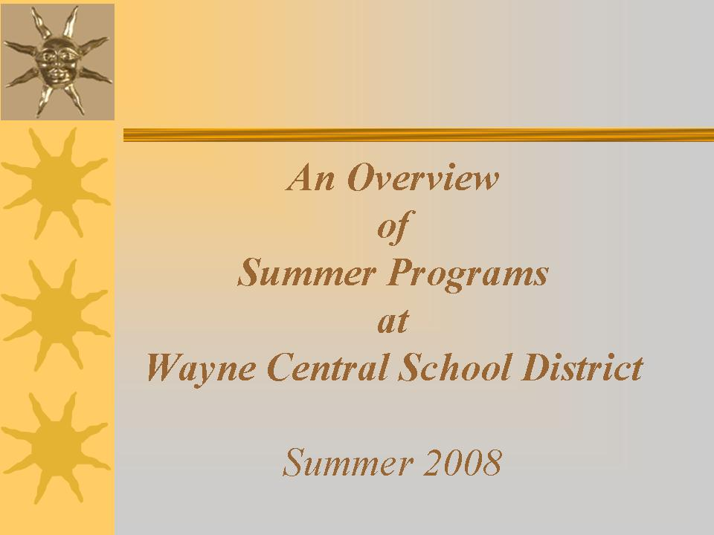

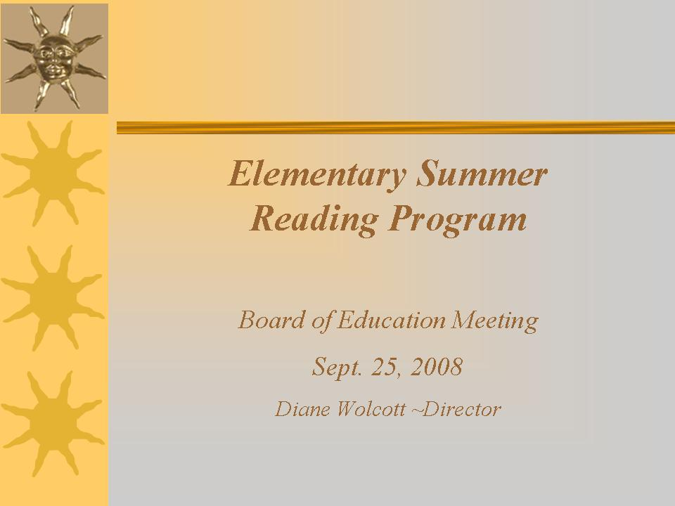



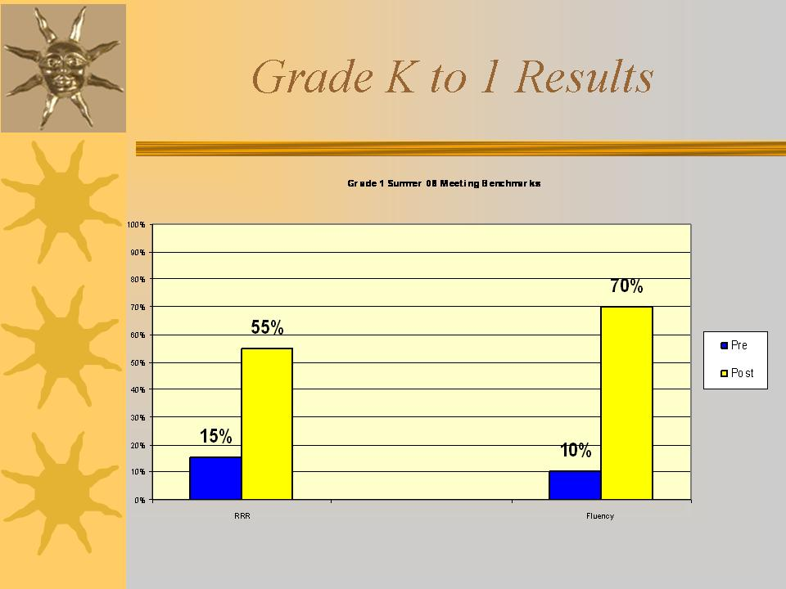

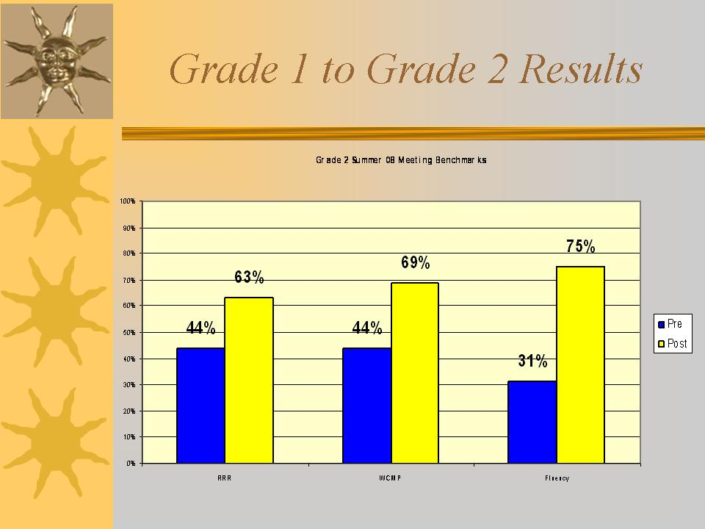
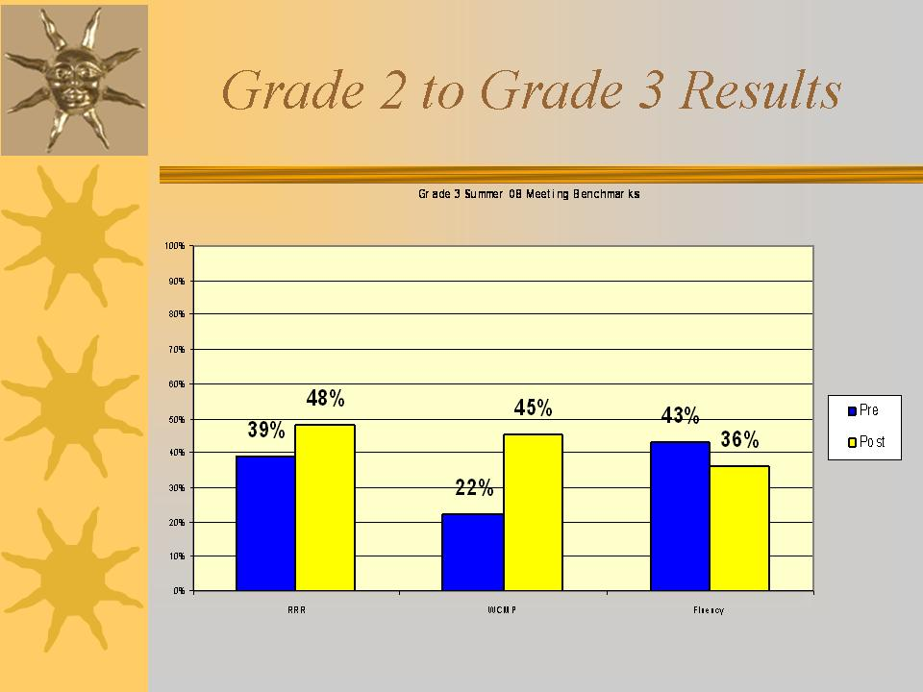

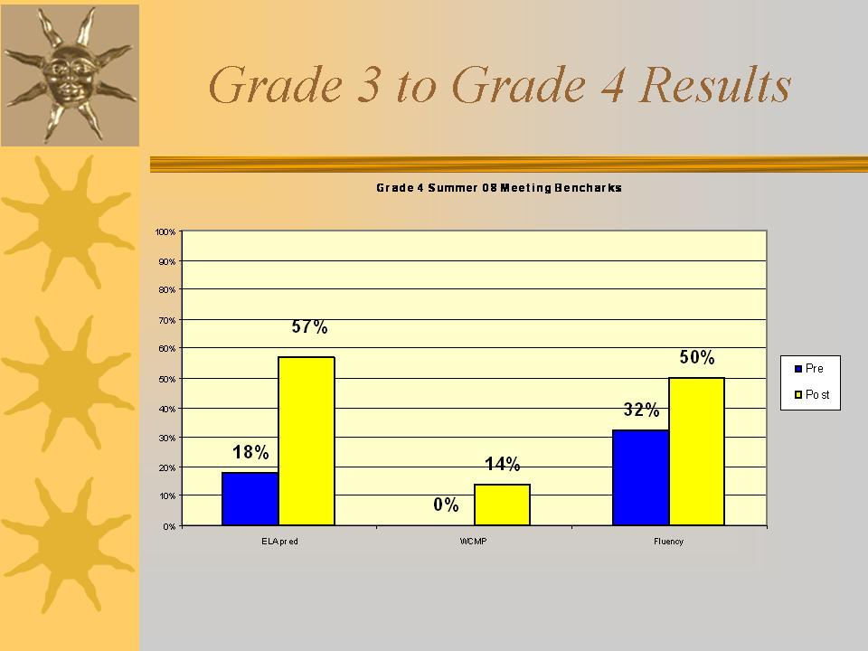
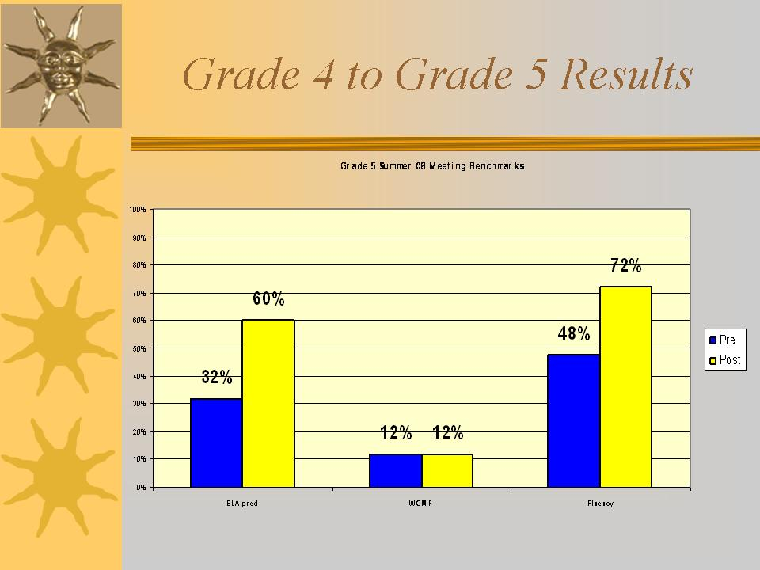

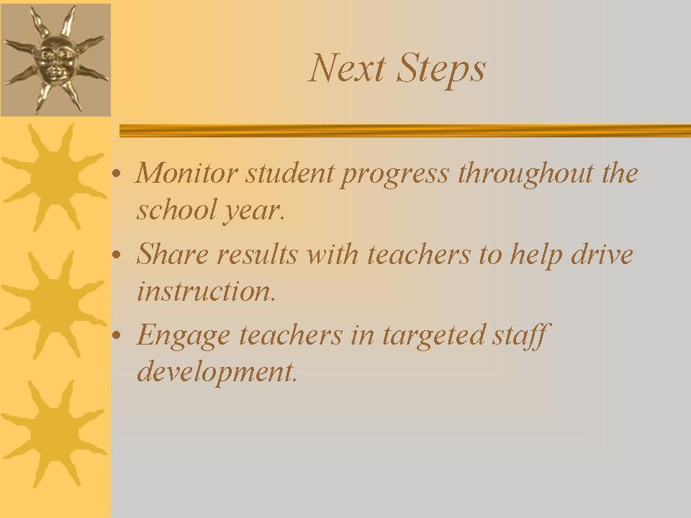
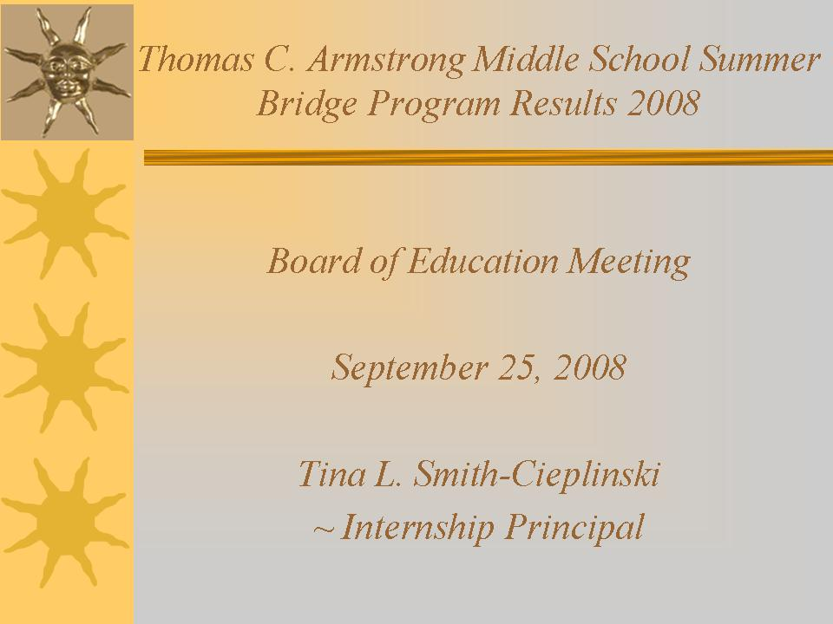




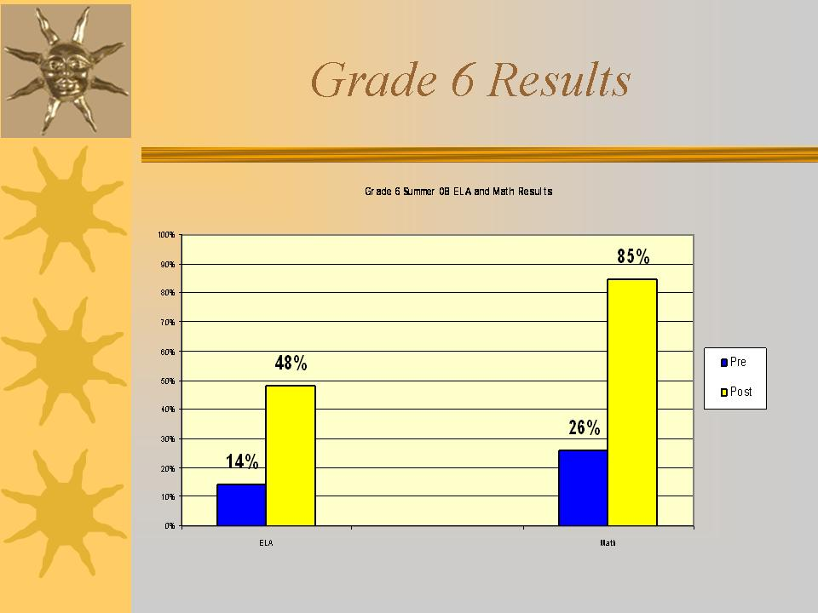

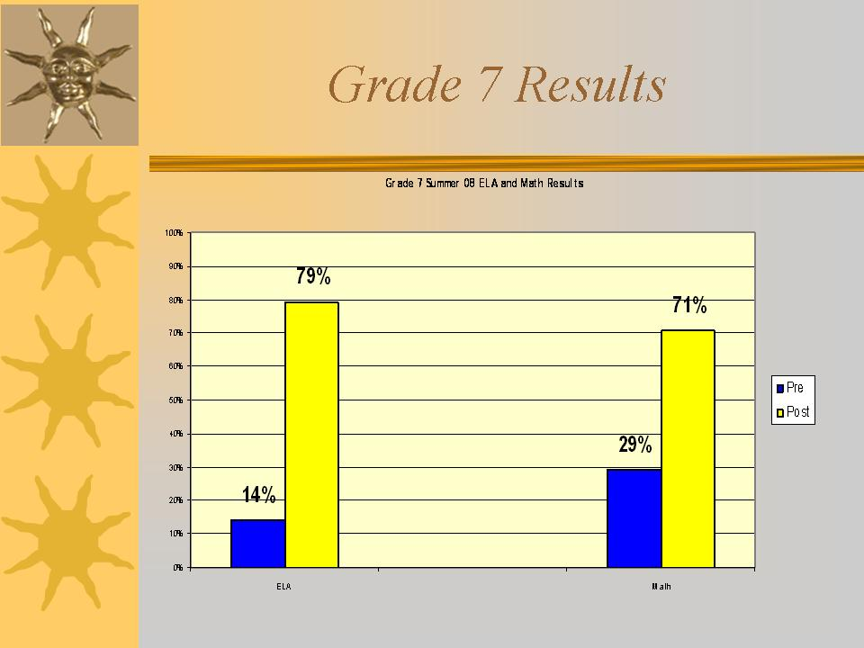

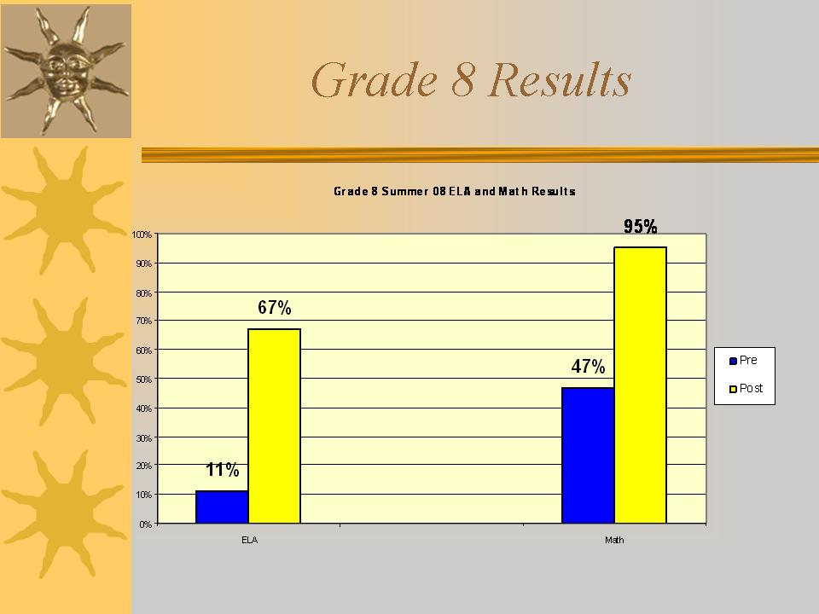
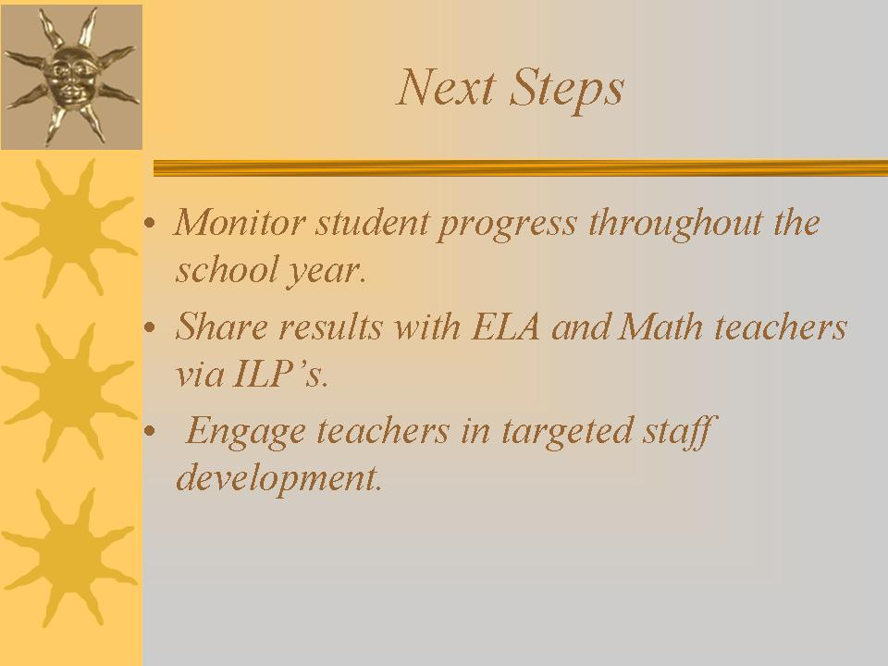

Att. 3

Wayne Central School District
Office of the Superintendent of Schools

Memorandum

TO: Board of Education, Michael Havens, Superintendent
FROM: Joe Siracuse
RE: Youth Assistance Program
DATE: Sept. 19, 2008

An informational presentation on the Youth Assistance Program will be presented to you by Trooper Robert Chapman and me at the Sept. 25th Board of Education meeting. The Youth Assistance Program targets students who have exhibited high risk behavior. This program is designed to provide students with the opportunity to gain understandings and insights from those that have learned from their previous mistakes. The goal is to help students to change the direction their lives are taking and to avoid similar consequences.

If you have any questions about this presentation, please feel free to contact me.

